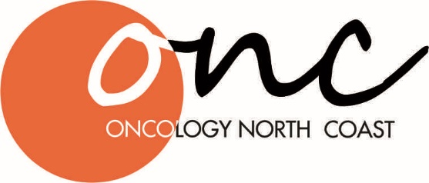
Oncology North Coast
55 Avondale Ave
East Lismore NSW 2480
p.0266221865 f.0266221738
Patient referral

Doctor: | Dr Adam Boyce |  |  | ☐ | Dr James Bull |  | ☐ | Dr Amy Scott |  |  |  | ☐ | Dr Mark Flower | ☐
Patient details:
First name: |  | Click or tap here to enter text. |  |  |  | Surname: |  |  |  | Click or tap here to enter text.
DOB: |  | Click or tap to enter a date. |  |  |  | Gender: |  |  |  | Choose an item.
Contact: |  | Click or tap here to enter text. |  |  |  | Name if not patient |  |  |  | Click or tap here to enter text.
Address: |  | Click or tap here to enter text.
Clinical details:
Case History:
Click or tap here to enter text.

Diagnosis: |  | Click or tap here to enter text.
Details of investigations:
Histopathology |  | Click or tap here to enter text.
Scans |  | Click or tap here to enter text.
Referring Doctor
Name: |  |  | Click or tap here to enter text.
Provider No.: |  |  | Click or tap here to enter text.
Address: |  |  | Click or tap here to enter text.
Phone: |  |  | Click or tap here to enter text. |  |  |  |  |  | Fax: |  | Click or tap here to enter text.
Signature: |  |  |  |  |  |  |  |  | Date: |  | Click or tap to enter a date.

